DAT-300 Project Two
Karver Stockstill
Karver.stockstill@snhu.edu
Professor Pettit
Southern New Hampshire University

Current and Future States
Based on the existing categorical trends in the organization's sales, profit margin, and inventory levels, it is not currently possible to make future predictions or decisions about revenue outcomes. This can lead to a potential issue of overs or understocking products, leading to a decrease in sales causing unnecessary costs for the organization. Sales and profit show a directly effect from inaccurate understanding of product and regional performance, creating marketing gaps and missed opportunities creating sale increases during the lower performing months that could lead to a more consistent yearly profit. We can use this approach when considering the already high sales producing products and months, allowing for an overall growth in revenue for the organization. It is important to identify and understand the high revenue producing months and categories to highlight a higher profit margin.
The ability to understand and observe the patterns that the organization is producing is key to obtaining revenue growth. Identifying the products that produce the most profit can help the organization maintain a proper inventory count, eliminating issues that could occur with inventory over or understocking. Understanding why certain regions underperform can help the organization provide additional support to those areas. To obtain this goal the need to predict future outcomes based on past datasets that lean more towards items purchased as well as in depth of inventory procedures: date of when inventory products are ordered/received, quantity during the high producing months compared to lower producing months, rate of quantity sold during high profit months. Having this information, we can ensure that the organization’s inventory stays in conjecture to the profit they are already seeing from the data. This also allows the organization to focus on the months, products and regions that are under-performing by increased advertising and marketing strategies, adjustment of product/shipping prices that are more aligned with the market, and overall customer satisfaction (Team, 2025).
Identification of the Gap
Based on the available data, there is limited information regarding the conditions that influence profit and revenue fluctuations across specific months, products, and regions. Without identifying sales trends, including peaks and troughs, the organization may not be able to adjust marketing and operational strategies effectively. This could result in lower performance and reduced ability to demonstrate organizational capabilities. Revenue generated from lower-performing products, months, and regions can potentially be allocated to higher-performing stores—through product inventory or increased marketing—to improve overall revenue without incurring additional costs.
Consequences of doing nothing with the current gap situation could lead to a loss in revenue with the potential increase in unnecessary costs, and loss of regional locations due to consistent underperformance. Undiscovered sales prospectives due to missed marketing and advertising opportunities due to high revenue on lower and slower selling products may directly and indirectly affect profit the organization sees.
Moving from Current to Future State
The following steps are necessary to address the recognized data gaps. This is crucial for developing strategies to build the bridge that moves the organization into the future state desired. Once we can obtain the data needed on inventory procedures that include quantity ordered, quantity sold we can better understand the peaks and dips seen in the current state data. Software such as Microsoft BI provide perspectives into the exiting trends, season sales, and over revenue production. Once the new data needed gathered, predictive analysis along with visualizations can create a fresh marketing and advertising strategy. These strategies will help in both high revenue locations and months along with lower producing areas, all while ensuring little to no additional costs. Additionally, to move from current to future state, the organization could create an automated order option for high revenue producing products once reaching a low inventory level to ensure that those are always readily available for customers further helping increase organizational revenue.
Gap Analysis Visualizations and Summary
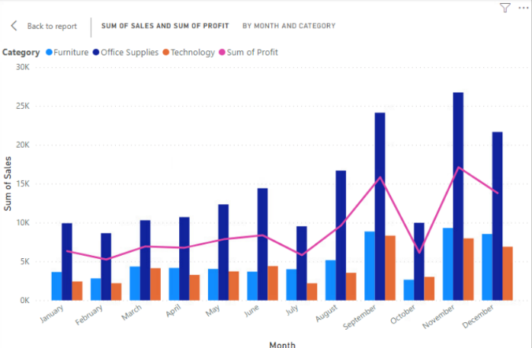
The visualization above shows the sum of sales that occur throughout the months regarding the categories within the organization: furniture, office supplies and technology. From this graph we can see that office supplies continuously show the most sales, with furniture maintaining a close second and technology typically showing the lowest performance. We can see peaks in the months of June, August, September and November, and dips within the months of February, July, and October. Withing this visualization we can see a profit line graph that very closely resembles the peaks and dips seen throughout the sales. Showing that profit strongly aligns with the sum of sales. This graph illustrates the importance of analyzing the factors contributing to sudden declines in sales.
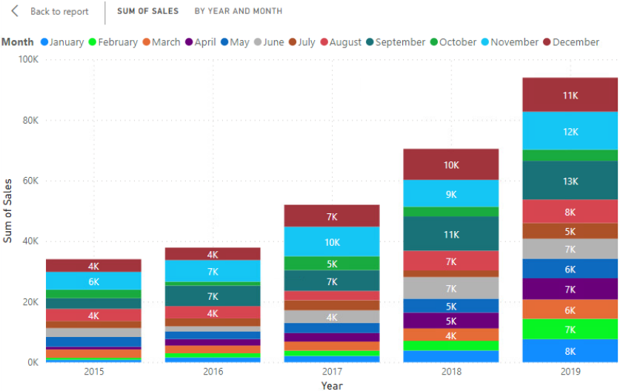
The visualization above helps in showing that as we saw in the previous visualization in regards to months we can see how the months are effected through the years. We see that the overall sum of sales is continuing to grow as each new year progresss, but we still see the same instances of little sales showing a drastic dip from one month to the next. This helps in establishing that these months are an area for concern that has show consistency throughout the years.
The graph below shows the profit related to sub-category sales withing the organization. We can see clearly that binders and papers are the lead in profit. This observation aligns with the previous graph of monthly sales and profit with office supplies continuously producing the highest revenue. From this graph we can see the prioritized inventory needed to maintain current profit margins, also the question of these supplies inventory within the months that we see a dip and whether there is a direct relationship between them. Ensuring that these supplies stay consistently stocked and accessible to customers could potentially result in increased revenue. Also, understanding the lower selling items is key to understanding overall revenue. We see that copiers and machines are the lowest, which again aligns with technology providing the lowest profit. Considering inventory of these items to ensure that there is no unnecessary cost related to them and that there is not an abundance of inventory on an item that is not selling will help save overall costs and produce a higher revenue.
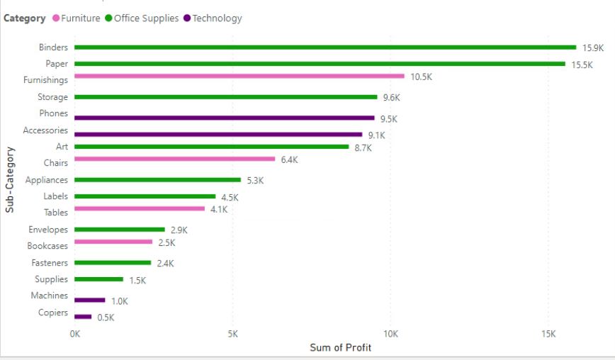
The graph below helps to better understand regional monthly sales. Throughout the year, except in the month of December the southern region shows the lowest profit. This helps to establish potential problems that could be in direct relation to low sales. It is able for the organization to focus specifically on that region knowing that the profit margins in other regions are more suitable. Seeing how the month of December is the only time that the southern region was able to produce higher sales; questioning if this is due to a season factor. Understanding customer satisfaction and needs during this month and adjusting marketing strategies in alignment of usage throughout that month.
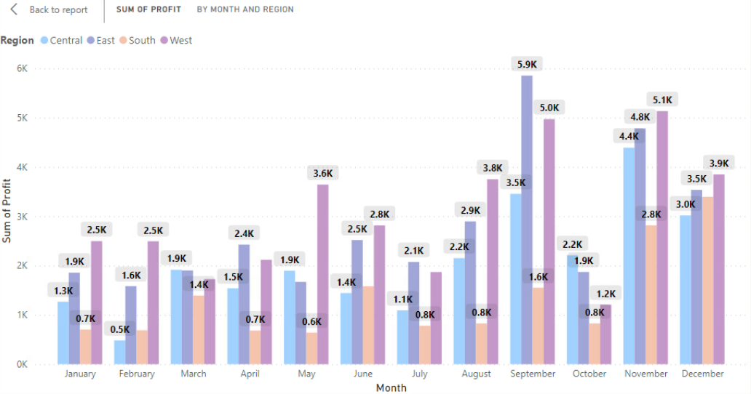
Extract, Transform, Load (ETL) Process
The ETL process involves extracting, transforming, and loading data throughout different resources and transforming that data into one source for use on future reports and analysis. During the extracting process, the data obtained comes from various sources and formats. This step also involves checking for accuracy, redundancy, and any missing data all to ensure that the data is dependable. Extracting data related to inventory quantity, order, and sale rate within the organization is imperative to close the gap. These extractions may be on the same source as the data already provided, leaving only the need for cleaning and assessing for missing data. Obtaining data from sources regarding marketing and advertising strategies as well as regional information may include different source information, formatting this data must occur before looking at the data any further. After extracting the necessary data, understanding the format used by the organization is essential so that analysis can start. While transforming data scanning for any data not pertinent to the organization current needs help in establishing data that flows easy for all to understand. For instance, when obtaining data on regional sales, inventory sales and orders there is no need for employee information about who made the orders or who completed sales. The most essential information is what is related to the organizational questions. After the extracting the data, cleaning, and transforming it into one format the loading of the data into the correct data warehouse occurs so analysis can begin. The ETL process is important for obtaining data from multiple sources, cleaning and transforming the raw data into clean accurate and reliable form that allow organizations to make quality strategic decisions (Geeks, 2025).
Handling Sensitive or Confidential Information
The information provided through the data set had no direct personal or sensitive data. It is good practice to go through the necessary data security procedures within the organization. With the sensitive organizational data provided such as overall profit, revenue and product profit management, authorized personnel should only have access. Providing employees with education and training on the proper handling of sensitive information in accordance with organizational procedures is essential (Redactable, 2025). It is also important to clarify protocols for data sharing and highlight the significance of maintaining security when managing data.
Production and Testing Environments
A sandbox environment is useful when testing models, ensuring the preservation of data integrity. Sandboxes use a copy of the production data for data exploration, testing and various hypothetical approaches all without effecting the production environment (Geeks, 2023). By using a sandbox environment, the organization can test different paths for producing an increase in revenue, ensuring that the methods were effective and working withing the desired outcomes before making it live. These test can help ensure that minimal or no disturbances will occur once deployed.
The test process involves predicting and analyzing new inventory stock, sales, and marketing points scenarios for accuracy, while also monitoring for potential disturbances and negative results. Once validated and aligned with organizational goals, the successful tests become a part of the production system. The system undergoes ongoing updates utilizing the most current information sourced from real-time data.
Additional Data Resources
Additional data that could be useful in creating an increase in overall revenue is competitor sales data and seasonal data. By obtaining the competitor’s sales data we could create our own visualizations and compare them with ours to see if both organizations are achieving the same peaks and dips. If not in alignment, looking into what the competitor does differently in the months that we see a dip in our revenue and profit. This is useful in seeing if competitors offer cheaper prices or have a different marketing strategy that is more alluring to customers. Comparing seasonal sales help to see if there is a potential revenue increase in those months if competitors are achieving higher profit margins. Adjusting strategies within those months can add to the already high revenue and profit seen in the data.

Resources
Redactable. (11 June, 2025). How to handle sensitive information or records securely. How to Handle Sensitive Information or Records Securely
GeeksforGeeks. (23 July, 2023). Importance of Analytical Sandbox. Importance of Analytical Sandbox - GeeksforGeeks
Team, Indeed Editorial. (6 June, 2025). 20 Strategies To Increase Revenue. 20 Strategies To Increase Revenue | Indeed.com
GeeksforGeeks. (19 July, 2025). ETL Process in Data Warehouse. ETL Process in Data Warehouse - GeeksforGeeks

